Reg Stats Style Guide

# Purpose of Reg Stats

The purpose of the Reg Stats page is to provide visually appealing charts that accurately communicate data that is important to or featured in our research.

# Color Scheme for Charts and Graphs

## GW Color Schemes

GW’s color palette for items intended for online use are separate from those in the [Identity Standards](https://creativeservices.gwu.edu/sites/g/files/zaxdzs1101/f/downloads/GW_Identity_Guidelines_v1-1_0.pdf). Details for GW Web Colors are as follows:

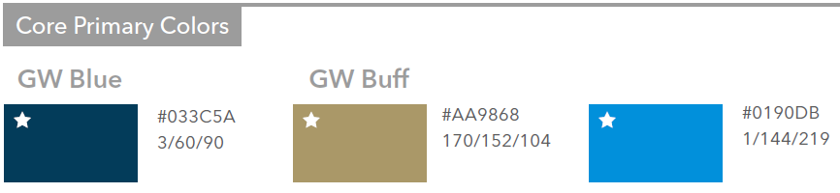

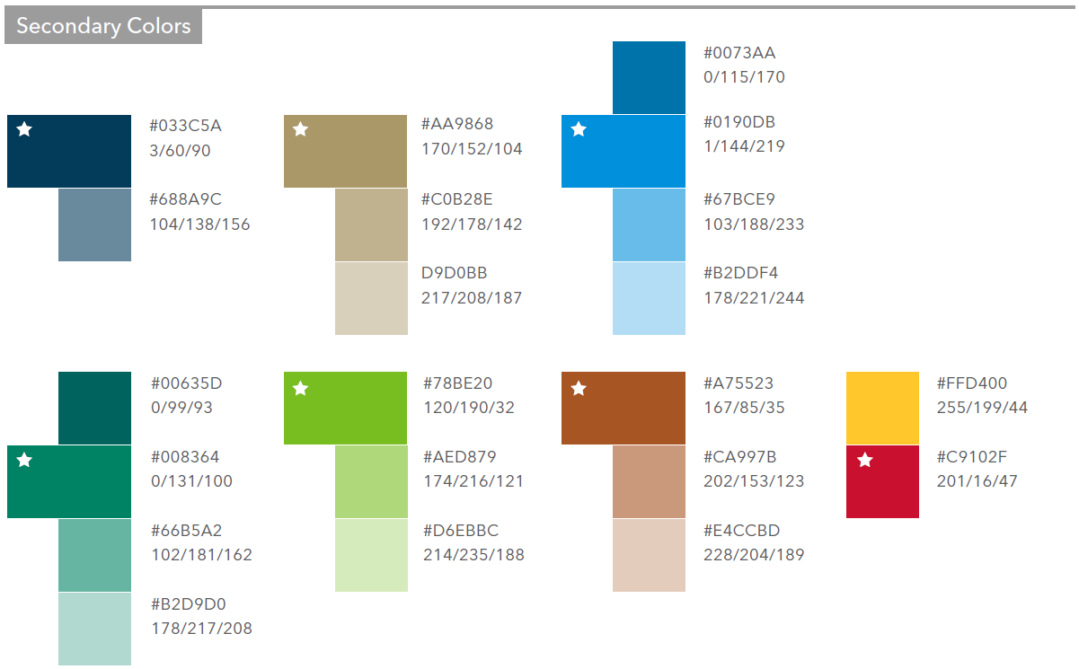

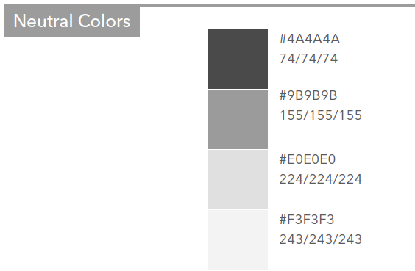

Use a white background for all charts and graphs.

* Do this in Excel: Right click on the plot area > Shape Fill > Select a color.

Use a standard black for all axis labels.

Use the GW Blue for Democratic administration data and the Secondary red for Republican.

If a graph or chart calls for three or more colors, use the above colors in the following order:

1. GW Blue
2. GW Alternative Blue
3. GW Buff
4. Secondary red
5. Secondary teal
6. Secondary green
7. Secondary yellow
8. Secondary brown
9. Neutral colors

# Formatting for Charts and Graphs

## Fonts

For all Reg Stats charts, the primary font is AvenirNext LT Pro Regular

* If the font is too wide for axis labels, use Avenir Next LT Pro Condensed
* All other fonts should only be used if necessary

All charts will use the GW font package. The main fonts are

* AvenirNext LT Pro Regular
  + *AvenirNext LT Pro Italic*
* AvenirNext LT Pro Medium
  + *AvenirNext LT Pro Medium Italic*
* **AvenirNext LT Pro Bold**
  + ***AvenirNext LT Pro Medium Bold***
* Avenir Next LT Pro Condensed
  + *Avenir Next LT Pro Condensed Italic*
* **Avenir Next LT Pro Bold Condensed**
  + ***Avenir Next LT Pro Bold Condensed Italic***
* Hoefler Text Regular
  + *Hoefler Text Italic*
* Hoefler Text Bold
  + *Hoefler Text Bold Italic*
* Hoefler Text Black
  + Hoefler ext Black Italic
* Liberator Light
* Liberator Medium
* Liberator Heavy

## Formatting

All formatting should be simple and easily readable.

If necessary, make lines and bars thicker to provide more visual appeal.

* Do this in Excel: Right click on the line/bar > Format Data Series > Line Style > Increase or decrease the width or change the compound type.

Each chart should include a Title (size 20 font), X & Y-axis labels (12 font), GW Reg Studies logo (copied below), data source (11 font), and the date of when it was last updated (11 font). You can adjust font sizes as needed.

In the chart below, the X-axis text is at a -65 degree rotation. The tick mark lines are a 0.1 pt width, Black in color, with a 60% transparency. The gap width between lines is 100%.

The bars for Democratic administration data are in patent fill (Dotted: 75%), foreground = GW Blue, and no border line. The bars for Republican are in solid fill, color = Secondary red, and no border line.

The chart is placed on a separate Letter page (Page Setup – Paper Size=Letter).

The RSC log has a ‘Height’ of 0.81” ‘Width’ of 2.49”, and its ‘Scale Height’ & ‘Width’ are at 30%.

To save a chart as a PDF file: follow the instructions [here](https://www.investintech.com/resources/blog/archives/8125-how-to-excel-chart-to-pdf.html) (go to Extract Excel Chart to a PDF (Exact Dimensions)).

## Example:

## 

## Logo Image File:



To create space at the bottom of the chart, click a space between the Y-axis lines within the chart itself and drag the ‘chart area’ inward as needed.

The logo should be aligned with the left edge of the X-axis text, and the Source text should be along the right edge of the chart. The bottom of the logo and the text box should be aligned.

Copy the logo image file above and paste it into your Excel file, then select the image and select Size & Properties in the Format Picture window, and check the ‘Lock aspect ratio’ and ‘Relative to original picture size’ boxes. A universal ratio may not apply to all charts, but the above example has a ‘Height’ of 1.08” ‘Width’ of 3.32” and its ‘Scale Height’ & ‘Width’ are at 40%.

The logo should be hyperlinked to our website home page; https://regulatorystudies.columbian.gwu.edu/.

Insert a text box to put in the Source & Updated information. The Source should be hyperlinked with where the source of the data can be found.

This document serves as a guideline to follow. Use your best judgement for all charts!